PRESS RELEASE Contact: Katrina Ellis
katrina@flomenhaftgallery.com
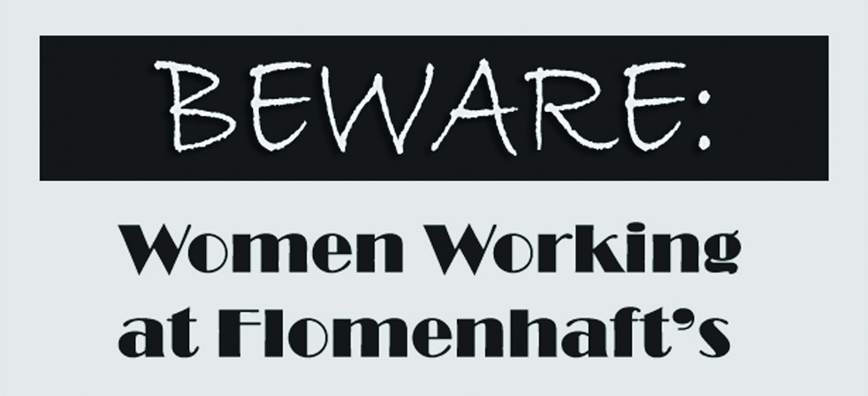

December 16, 2010 - February 19, 2011

The artists are an exciting group, celebrated by curators and museum personnel throughout the United States. Miriam Schapiro is credited with her contributions to the feminist revolution for good reason. Her early painting, "Fanfare," (1957) recently purchased by the Jewish Museum, on view there in the exhibition "Shifting the Gaze," and was used as their invitation image. From 1970 she paid homage to women's work, rescuing its images, decorative crafts and materials, and women's narrative expressionism. Faith Ringgold currently has a much touted exhibit at the Neuberger Purchase Museum. We are displaying a spectacular quilt from 1988, “Double Dutch on the Golden Gate Bridge." Jaune Quick-to-see Smith, of the Montana Flatheads, sees her mission in life to enlighten the greater community about her native view and to address our human and political condition. "Indian Hand" (1988) is a major work, which combines the richness of her inspirations from Rauschenberg, from Native American news flashes and native mythology.

Siona Benjamin, a recent winner of the Fulbright award, is a Bene Israel Jew from Bombay, India, and an American citizen. Having been educated in Catholic and Zoroastrian schools, her work relates to all outsiders, and is a draws influence from Persian miniatures, pop art and Hebrew midrashes. Flo Oy Wong is of the Chinese 'Paper People.' Her father came to this country at a time when wives were not allowed entry. By falsifying their papers and coming in as sisters, wives came here with children who grew up calling their fathers uncle. This secret is the inspiration of her much revered art, having had exhibits at Ellis Island and museums throughout the United States. Beverly Buchanan's shack paintings utilize pastels, and her shack architecture sculpture honors the tenant farmers of Georgia. Buchanan has had a major retrospective that travelled to ten museums, and will be given the lifetime achievement award by the Women's Caucus for Art in conjunction with the College Art Association Conference.

Another in our exhibit is Ellen Frank, whose CITIES OF PEACE® illuminated paintings were recently shown at Guild Hall, East Hampton, and featured in a recent New York Times article. They were also the first works to be exhibited at the Cathedral for St. John the Divine after its renovation, alongside the Cathedral's own Barberini tapestries. Amy Ernst, the granddaughter of Max Ernst and daughter of Jimmy, is a chip off the "old blocks." For 20 years, Amy's work has developed into its own, mostly using collage: the technique is nothing new, but the way the work is imagined, built and placed is uniquely her own. Dina Recanati's remarkable fabric landscapes and sculptures have had several museum exhibits as well as large scale public sculptures in Israel. Emma Amos, the only woman artist in the Spiral Group with Romare Bearden, and a luminous painter, has a lush new work entitled "Flight- A Fable." Linda Stein, whose tribute to all wonder women in painting and sculptures that represent female warriors, symbols of protection in a hostile environment, and whose sculptures are currently touring the United States. Mira Lehr, an abstractionist with a unique vision was recently artist-in-residence at the Bascom Center for the Visual Arts in North Carolina, and will be the next solo exhibition in the gallery. Joan Barber, whose paintings speak for everywoman's subconscious, has two works included, "Ghosts" and "Girl in Yellow Room.” Estelle Kessler Yarinsky is a fabric artist who weaves special narratives, and is included also, alongside Miriam Schapiro, in the current exhibition at the Hebrew Union College Museum, "A Stitch in Jewish Time: Provocative Textiles."

This is a big exhibit, a woman's show, timely considering the women's shows currently in major venues in New York City, and very worthwhile to view.
Flo Oy Wong
Mira Lehr
Amy Ernst
Miriam Schapiro
